# grep Assignment

**Mandatory:**

1. Use any .c file. Using grep command extract and display
   1. all lines beginning with #include with line numbers

Ans: grep -n “^#include” tst1.c

* 1. display all lines which do not begin with #include

Ans: grep -v “^#include” tst1.c

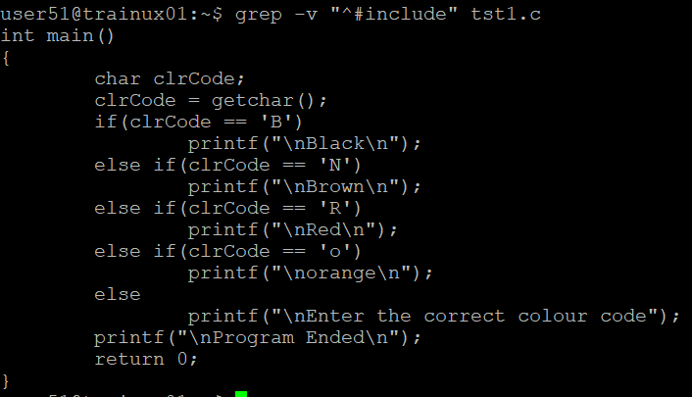

* 1. display the line number of main()

Ans: grep -n “^int main(“filename



* 1. extract all lines containing characters of opening and closing parathesis {(,))

Ans: grep -n “[{} ()]” filename

1. Perform the above operations on a set of *.c files

Ans: grep -n “^#include” *.c

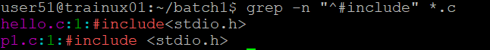

grep -n “^int main(“ *.c

